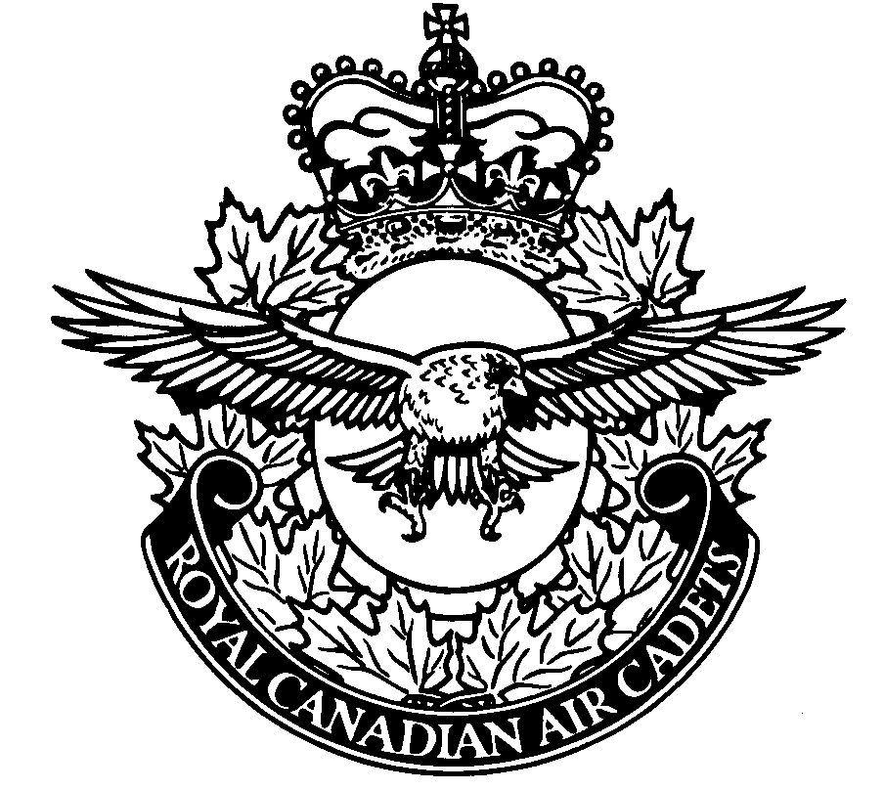STANDING ORDERS
Table of Contents
INTRODUCTION 2
PART 1 - TERMS OF REFERENCES 2
1.1 - COMMANDING OFFICER (CO) 2
1.2 - DEPUTY COMMANDING OFFICER (DCO) 4
1.3 - TRAINING OFFICER (Trg O) 5
1.4 - ADMINISTRATION OFFICER (Admin O) 6
1.5 - SUPPLY OFFICER (Sup O) 6
1.6 - CADET SQUADRON COMMANDER 7
1.7 - CADET DEPUTY SQUADRON COMMANDER 7
1.8 - SQUADRON WARRANT OFFICER (SWO) 8
1.9 - FLIGHT COMMANDER 8
1.10 - DEPUTY FLIGHT COMMANDER 8
PART 2 - DRESS AND DEPORTMENT 12
2.1 - DRESS 12
2.2 - DEPORTMENT 12
PART 3 - SQUADRON POLICY 10
3.1 - SMOKING 10
3.2 - ALCOHOL 10
3.3 - DRUGS 10
3.4 - HARRASSMENT 10
3.5 - ABUSE 10
3.6 - FRATERNIZATION 11
3.7 - ATTENDANCE 11

Part 4- SQUADRON ORGANIZATION

4.1 - SQUADRON ORGANIZATION CHART………………………………………………………………11
4.2 - WEEKLY TRAINING ROUTINE……………………………………………………………………….12

STANDING ORDERS

INTRODUCTION

1. Squadron Standing Orders are issued under the authority of the Commanding Officer. These Standing Orders outline the established policies and procedures as carried out by the Squadron and are to be adhered to by all cadets, civilian instructors and CIC officers.

2. The Standing Orders are to be reviewed by all members of Squadron prior to 31 Sep of each training year.

3. All cadets, civilian instructors and CIC officers will sign the Standing Orders annually indicating that they have read and will comply with all articles contained within these subject orders.

4. All cadets, civilian instructors and CIC officers who perceive a need to amend Squadron Standing Orders may make application to the Commanding Officer to amend those orders that are in question. At the discretion of the Commanding Officer, Standing Orders will be amended accordingly.

5. Standing Orders shall be reviewed on change of command by incoming Commanding Officer. The incoming Commanding Officer shall issue amendments at his/her discretion.

PART 1 - TERMS OF REFERENCES

1.1 - COMMANDING OFFICER (CO)
The Commanding Officer shall carry out all duties as outlined in CATO 11-36 ANNEX S. He/she is responsible to the Region Cadet Officer (RCO), through the Detachment Commander (Det Com), for all cadet matters, training and administration of Cadet Instructors Cadre (CIC) Officers, civilian Instructors, and cadets serving with the Squadron.

1.1.1 - COMMAND AND CONTROL:
With respect to matters of command and control, Squadron Commanding Officer shall:

A. Comply with the regulations and orders as issued by the Minister of National Defence and the Canadian Forces;

B. Keep CIC officers, civilian instructors and cadets of Squadron fully aquatinted with the regulations and instructions issued by a higher authority;

C. Be responsible for the professional development of all Squadron CIC officers and civilian instructors including him/herself and ensure they receive the training required by their appointments and terms of service;

D. Direct and supervise all duties of personnel under his/her control;

E. Appoint qualified officers to the following particular duties, ensuring deputies are provided during prolonged periods of absence:

(1) Deputy Commanding Officer (DCO),
(2) Supply Officer (Sup O),
(3) Training Officer (Trg O),
(4) Administration Officer (Admin O),

F. Appoint and reassign cadets to cadet duties and responsibilities within Squadron;

G. Ensure that proper supply, administration, financial and training orders and procedures are carried out;

H. Bring to the notice of the RCO any CIC officers or civilian instructors who:

(1) Are distinguished for proficiency in their duties;
(2) From incapacity or apathy, are deficient in the knowledge or execution of their duties;
(3) Do not afford him/her the support which he has a right to expect, and
(4) Conduct themselves in a manner detrimental to the Squadron’s efficiency or in a manner that would bring discredit to the Squadron and or the Canadian Forces;

J. Ensure an officer( i.e. DCO) is familiar with all Squadron procedures and is prepared to assume command either upon succession or during periods of prolonged absence of the Commanding Officer;

K. Ensure a thorough turn over to a successor, and

L. Undertake other duties assigned by the Regional Cadet Officer, the Area Cadet Officer or other lawful Canadian Forces authorities.

1.1.2 – ADMINISTRATION

A. In consultation with the sponsor, recommend enrollment, appointment, promotion, posting, transfer and release of CIC officers.

B. Recommend and document the appointment and release of civilian instructors of the Squadron;

C. Ensure that cadets are medically and physically fit to undertake the activities and training which they are expected to perform during local HQ or summer training;

D. Immediately report the death of a CIC officer, civilian instructor or cadet of the Squadron to the RCO, the ACO, and advise the sponsoring committee chairman;

E. Immediately document and report to the ACO and the sponsoring committee any injury incurred during Squadron training that requires medical treatment, that may result in permanent disability, and any other injury except a minor injury such as a superficial cut or bruise;

F. Report any significant incident/occurrence that may cause public interest to the RCO;

G. Ensure that funds provided by DND or other assisting agencies and any money provided by the sponsoring committee or raised by squadron is properly used for the benefit of the cadets.

1.1.3 – SUPPLY

A. Be appointed Squadron Distribution Account holder.

B. Immediately upon discovery report the loss or damage of DND equipment to the respective support base/station.

C. Insure that material on loan from support base/station is returned promptly.

1.2 - DEPUTY COMMANDING OFFICER (DCO)

1.2.1 - Squadron Deputy Commanding Officer shall be responsible to the Squadron Commanding Officer for carrying out all assigned duties.

1.2.2 - Shall carry out all duties as contained in CATO 11-36 Annex T and;

A. To assist the Squadron Commanding Officer with carrying out his/her duties;

B. To carry out all duties of Squadron Commanding Officer in his/her absence;

C. Carry out all other duties assigned to him/her by the Commanding Officer.

1.3 - TRAINING OFFICER (Trg O)

1.3.1 - Squadron Training Officer shall be responsible to the Squadron Commanding Officer for carrying out all assigned duties.

1.3.2 - Shall carry out all duties as contained in CATO 11-36 Annex U and also:

A. Developing a training program in accordance with established Cadet Training Directives as found in CATOs;

B. Preparing and maintained the annual training charts, 1964s, Individual Training Records, training files and other associated records;

C. Planning the yearly training schedule and assigning qualified instructors to individual classes;

D. Assisting and supervising instructors and senior cadets in the preparation and presentation of their classes;

E. Arranging to obtain guest speakers and other voluntary instructors to supplement Squadron staff;

F. Advising the CO on, and co-ordination of the Squadron’s special training projects, exercises and citizenship tours;

G. Selecting and submitting demands for training aids, office supplies and materials to carry out objectives of training program;

H. Ensuring Squadron is in possession of all required training material and reference manuals;

J. Organizing Squadron drill, ceremonial parades and inspections;

K. Ensuring that the training program is completed;

L. Recommend individual cadets for promotion and summer camp positions;

M. Carry out all duties assigned to Squadron Standards Officer in his/her absence; and

N. Carry out all other duties assigned to him/her by the Commanding Officer.

1.4 - ADMINISTRATION OFFICER (Admin O)

1.4.1 - Squadron Administration Officer shall be responsible to the Commanding Officer for carrying out all assigned duties.

1.4.2 - Carrying out all duties as contained in CATO’s 11-36 Annex V and :

A. Updating all cadets’, civilian instructors’, and CIC officers’ personal files.

B. Register and file all incoming and outgoing mail;

C. Confirm that all paid staff complete monthly pay sheets weekly.

D. At the end of each month submit all necessary documents regarding pays to the CO for his/her signature;

E. To complete all applications, memos and letters assigned by CO;

F. Distribute preliminary applications for Summer Training Courses to all cadets who show an interest in applying.

G. Carry out all other duties assigned by the Commanding Officer.

1.5 - SUPPLY OFFICER (Sup O)

1.5.1 - Squadron Supply Officer shall be responsible to the Commanding Officer for carrying out all assigned duties.

1.5.2 - Carrying out all duties contained in CATO 11-36 Annex W and also:

A. Ensure all cadets who have completed their enrollment and have demonstrated an interest in remaining with Squadron are issued uniforms;

B. Prepare all necessary documents to acquire equipment and uniforms for CO signature;

C. Maintain an updated record of all public property on the Squadron Distribution Account and all uniform parts belonging to Squadron (issued and non-issued);

D. Shall inform the Commanding Officer immediately of any lost or stolen public property or uniforms; and
E. Carry out all other duties assigned to him/her by the Commanding Officer.

1.06 - CADET SQUADRON COMMANDER

1.06.1 - Squadron Cadet Squadron Commander shall be responsible to the Commanding Officer, through the Training Officer, for carrying out all assigned duties.

1.06.2 - Shall carry out the following duties:

A. To assist in the implementation of the Squadron Training Program;

B. Enforce all rules and policies outline in these Standing Orders pertaining to all cadets in Squadron;

C. Ensure a high standard of dress and deportment is maintain by all cadets of the Squadron;

D. Bring forth concerns and suggestions of fellow cadets to appropriate staff members;

E. Keep all cadets of Squadron informed of all events and happenings through appropriate Flight Commanders;

F. Maintain a high standard of drill at all times; and

G. Carry out all other duties assigned to him/her by the Training Officer or Commanding Officer.

1.07 - CADET DEPUTY SQUADRON COMMANDER

1.07.1 - Squadron Cadet Deputy Squadron Commander shall be responsible to the Commanding Officer, through the Training Officer, for carrying out all assigned duties.

1.07.2 - Shall carry out the following duties:

A. To assist the Squadron Commander with carrying out his/her duties;

B. To carry out all duties of Squadron Commander in his/her absence; and

C. Carry out all other duties assigned to him/her by the Training Officer.

1.08 - SQUADRON WARRANT OFFICER (SWO)

1.08.1 - Squadron Warrant Officer shall be responsible to the Training Officer, through the Squadron Commander, for carrying out all assigned duties.

1.08.2 - Shall carry out the following duties:

A. Taking of attendance of weekly training nights and all training activities;

B. Reading of WRO’s to all subordinate cadets;

C. Calling of absent cadets;

D. To assist the Squadron Commander with carrying out his/her duties; and

E. Carry out all other duties assigned to him/her by the Training Officer.

1.09 - FLIGHT COMMANDER

1.09.1 - Squadron Flight Commander shall be responsible to the Training Officer, through the Squadron Commander, for carrying out all assigned duties.

1.09.2 - Shall carry out the following duties:

A. Ensure cadets are informed of all events and any changes to announced previously events;

B. Ensure cadets in their flight are in proper dress and well turned out for training nights;

C. Supervise all cadets in their flight; and

D. Handle minor disciplinary problems in their flight.

1.09 - DEPUTY FLIGHT COMMANDER

1.09.1 - Squadron Deputy Flight Commander shall be responsible to the Training Officer, through the Squadron Commander, for carrying out all assigned duties.

1.09.2 - Shall carry out the following duties:

A. To assist their respective Flight Commander with carrying out his/her duties;

B. To carry out all duties of their Flight Commander in his/her absence;

C. Carry out all other duties assigned to him/her by the Training Officer.

PART 2 - DRESS AND DEPORTMENT

2.1 - DRESS
All Members of the Squadron will adhere to the following Squadron Dress regulations:

A. All cadets shall conform to the Air Cadet Dress Regulations, CATO 55-04,
while in uniform;

B. All CIC Officers shall conform to the Canadian Forces Dress Regulations.

C. Under no circumstances shall civilian articles of clothing be worn with any
part of an Air cadet or CIC uniform;

D. All Civilian Instructors shall wear appropriate attire during Squadron training nights and training activities;

2.1.1 - The following is the order of dress for:

Cadets Officers Civilians
(Winter)
Regular Training Night C-3 3 C informal

(Summer)
Regular Training Night C-2 3 B informal

CO’s Inspections C-2 1 D Semi-formal

2.2 – DEPORTMENT

2.2.1 - All members of Squadron including, cadets, civilian instructors and CIC officers shall conduct themselves in a professional and responsible manner at all times.

2.2.2 - Cadets, and CIC officers while in uniform shall not chew gum, slouch, saunter, place hands in pockets, smoke, walk arm in arm or similar deportment that detracts from a military bearing in the eyes of the public.

PART 3 - SQUADRON POLICY

3.1 – SMOKING

3.1.1 - Under no circumstances shall cadets smoke or be in possession of tobacco products.

3.1.2 - All staff, including civilian instructors and CIC Officers, shall not smoke in front of Squadron’s or any other Squadron’s cadets.

3.2 – ALCOHOL

3.2.1 - No cadet shall consume or be in possession of alcoholic beverages or be intoxicated during Squadron activities.

3.2.2 - No Squadron staff member, including civilian instructors and CIC Officers, shall consume or be in possession of alcoholic beverages or be intoxicated while performing their duties as a CI or CIC Officer.

3.3 – DRUGS

3.3.1 - No member of Squadron, including cadets, civilian instructors and CIC Officers, shall be under the influence of or be in possession of any illegal drug of any sort.

3.3.2 - Squadron Commanding Officer shall immediately notify proper local authorities of any breech of para. 3.3.1 above.

3.4 – HARRASSMENT

3.4.1 - Under no circumstance shall members of Squadron, including cadets, civilian instructors and CIC Officers, exhibit conduct that offends, demeans, belittles or humiliates another person.

3.4.2 - All infractions of CFAO 19-39 (Canadian Forces Policy of Harassment) will be reported to the Commanding Officer or the immediate supervisor (officer) of the harassed.

3.5 – ABUSE

3.5.1 - Under no circumstances shall members of Squadron, including cadets, civilian instructors and CIC Officers, abuse or be abused by another person, whether that be emotionally, physically, verbally or sexually.
3.5.2 - All infractions of CATO 13-24 (Emotional, Physical and Sexual Abuse in the Canadian Cadet Organization) will be reported to Commanding Officer or the immediate supervisor (officer) of the abused.

3.6 – FRATERNIZATION

3.6.1 - Under no circumstances shall members of the Squadron display or engage in any act of a sexual nature.

3.6.2 - Cadets shall not openly display acts of affection while at a Squadron activity.

3.7 – ATTENDANCE

3.7.1 - All Squadron Cadets must maintain a minimum 60% attendance rate throughout the cadet training year.

3.7.2 - Subsequent to para. 3.7.1, any cadet who is absent for three or more training nights in a row shall be SOS and recovery action for uniform undertaken.

3.7.3 - It is the responsibility of the individual cadet to inform the Squadron Commander, Trg O or Admin O of his/her reason(s) for being absent from a Squadron training night or compulsory training activity.

PART 4 - SQUADRON ORGANIZATION

4.1 - SQUADRON ORGANIZATIONAL CHART

4.2 - WEEKLY TRAINING ROUTINE

 | Event | Start | End | Remarks
Sunday | Squadron sports | 09:00 | 12:00 | Rec Centre
Monday | Admin night | 18:30 | 21:00 | Officers only
Tuesday
Wednesday
Thursday | Training parade | 18:30 | 21:00 | See schedule
Friday | Movie night | 19:00 | 23:00 | Squadron HQ
Saturday | Drill team practice | 10:00 | 12:00 | Drill Hall

Thursday Training Schedule

18:30 | Fall in (WOs, F/Sgts, Sgts 18:15)
18:30-18:45 | Uniform inspection/Attendance
18:50-19:25 | First period of instruction
19:25-20:00 | Second period of instruction
20:00-20:15 | Break
20:15-20:50 | Third period of instruction
20:50-21:00 | Announcements/ Dismissal

