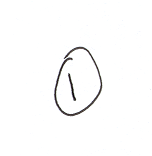
MEMORANDUM

1085-10 (Admin O) <- Originator in brackets

19 Feb 98 <- Short date

CO <-Full address of addressee not needed.

MILITARY CORRESPONDENCE <- Subject capitalized and underlined

Ref: Telecon CI/Stds O 18 Feb 98 <- Not lettered if only one reference

1. This is the format for a memo on a blank sheet of paper. This format should be followed for all internal correspondence i.e. within your own squadron.

2. It is requested that this memo be forwarded to the CO.
1-1^{1/2}” 1” Margin

Margin
<- 6 Spaces. You will see less space used in order to keep memos at one page
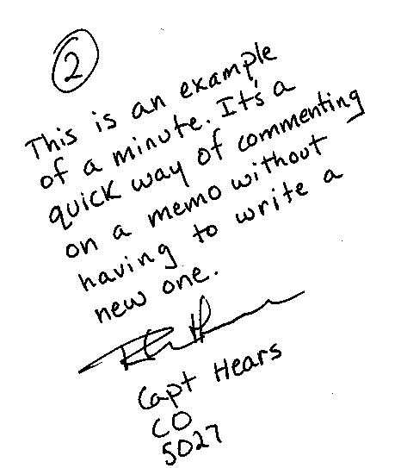

C.D. Speaks
Lt. <- memos use abbreviations
DCO
DCO
5026 <- local phone number

