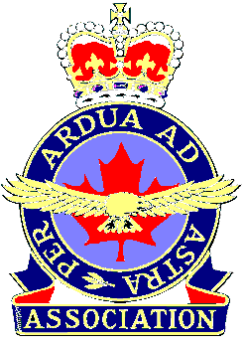

Our History

The Royal Canadian Air Force Association was formed in 1948 as a national advocacy group to support the Royal Canadian Air Force, and to unite Air Force veterans of the Second World War.
Former Chief of the Air Staff, Air Chief Marshal LS Breadner accepted the task of organizing the new association. He successfully enlisted the participation of various community groups and clubs of former airmen and airwomen, and also invited unaffiliated air veterans to join as members-at-large.
An Order-in-Council legitimized the new association. With Treasury Board funding and headquarters accommodation provided by the Department of National Defence, the RCAF Association held its first annual meeting in Ottawa, 16 September, 1948 at which ACM Breadner was named the first Dominion President. Much organizational and administrative work followed, and the first membership cards were issued in February 1949.

Constitution and Bylaws were framed so that the Association could be incorporated under the Companies Act. A Charter under the Act was granted by the Secretary of State of Canada, on 14 May 1951. Over the years the Association grew and prospered, closely linked with the Royal Canadian Air Force. However, in 1968, the RCAF ceased to exist with the unification and integration of Canada's three armed services. This event resulted in a gradual disconnect between the RCAF Association and Canada's air element, redressed to some degree with the formation of Air Command in 1975. Air Command then became the focal point for all regular and reserve Air Force activity. In 1992 it challenged the RCAF Association to re- position itself as both an advocacy group and a focal point for Air Force veteran activity.

Following nearly 30 years after the demise of the RCAF, a name change for the Association was proposed by Air Command to reflect that reality. A change of name was an emotional issue, and the proposal was exhaustively debated within the Association for more than a year before it came to a vote at the annual convention in Winnipeg in October 1993. The vote was overwhelming, with 82.6% of delegates in attendance voting in favor of a name change.

On 1 July, 1994 the Air Force Association of Canada became the new official title of our Association. Over the following two years, the membership of the Association has grown by 30%, to nearly 16,000 regular wing members and members-at-large, and an estimated 5,000 associate members. There are 74 Wings or chapters across Canada and in the western United States (California and Colorado). Wings actively sponsor and support air cadets and other community activities.

Nationally, the Association is a strong advocate of a professional and well-equipped Air Force for Canada, and is an active advocacy of veteran’s rights through membership in the National Council of Veteran Associations.

Our Guiding Principles

The Association shall be democratic, non-sectarian and shall not be affiliated or connected directly or indirectly with any political party or organization.
The Association shall stand for loyalty to the reigning sovereign and the principles of democratic and ordered government, for a national and united spirit, and for strong and united comradeship among all who have served in military or civil aviation.
The Association shall be an all-ranks organization insofar as its military or ex-military members are concerned and no member shall be entitled to precedence for any reason other than by virtue of elected standing in the Association.

Our Mission Statement

The Association is a national not-for-profit aerospace and community service organizations composed of aviation-minded citizens established to remind Canadians of their country’s rich aeronautical tradition and history, to support Canada’s Air Force and to support and encourage the civil aviation component within the country.

Our Objectives:

To preserve and perpetuate the glorious traditions of the Royal Canadian Air Force and all who served in it.

1. To provide a forum for serving and former participants in military and civil aviation.

2. To sponsor and encourage aeronautics in all its forms and branches.

3. To support Air Cadets and work closely with the Air Cadet League of Canada, and to participate in local civic and community programs, especially those designed to develop the physical, mental and moral well-being of our nation's youth.

4. To undertake charitable and other projects of both a national and local character.

5. To work with the RCAF Benevolent Fund and various veterans organizations in the attainment of their objectives.

6. To promote and encourage responsible citizenship among all Canadians.

7. To advocate a proficient and well equipped Air Force in Canada.

More Info:

For further information on the Air Force Association of Canada, contact us at Tel. (613) 992-7482 or FAX (613) 995-2196, or write to us at Executive Director, Air Force Assn. of Canada, PO Box 2460, Stn "D" Ottawa, Ont. K1P 5W6.

Our Symbols...

THE AIR FORCE ASSOCIATION BADGE

For the first few months following the RCAF Association founding in 1948, the Association used the RCAF badge. However, the Judge Advocate General of the Royal Canadian Air Force criticized this action by the Association, and in late 1949 an RCAF Association badge was introduced. The badge was informally brought into use. The design was never researched or copyrighted, nor was design approval sought from the RCAF.

It wasn't until the late 1950s when the RCAF advised the Association that the "unapproved" badge was inadequate have to go; it did not meet with official criteria established by the Air Force. It was then that RCAF graphic artist Harold Diceman was tasked with the design of a heraldicly correct badge for the RCAF Association.

Pre-1949

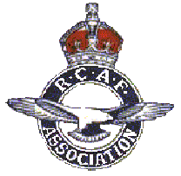
Serving on the National Executive Council at the time was Mr. George Penfold of Don Mills, Ont. who later went on to become national president in 1964-65. With some humor, he recalls that the design criterion that was established by the RCAF was most demanding. Mr. Diceman was sent back to the drawing board more than once to come up with an "old" eagle that differed substantially from the smooth-feathered bird that graced the official badge of both the RCAF and the RAF. Eventually, the Association's eagle looked old and ruffled enough to be instantly recognized as a "veteran," and the design was put forward for Royal approval.

1949-1960

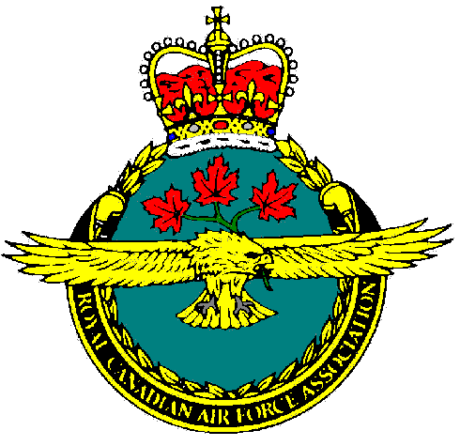
Royal approval was received in May 1960, when Her Majesty Queen Elizabeth II signed the design. There was just enough time to rush into production an Association banner emblazoned with the newly approved badge. The Banner was proudly paraded at the 20th anniversary ceremony of the Battle of Britain, on Parliament Hill in September, 1960. At the annual general meeting in October 1993 the delegates voted to accept the challenge put forward by Air Command to change the name of the Association from the RCAF Association to Air Force Association of Canada.

1960-1994

Effective July 1st, 1994, the Air Force Association came into being and with it a newly designed badge. An Association member, Bruce Beatty of the Canadian Heraldic Authority, came up with the design. Approved by Her Majesty, the present badge features a single, central stylized maple leaf, emblazoned with a gold eagle, and topped by the Royal Crown. An outer circle bears the Association's motto "Per Ardua Ad Astra". A bold, simple design that communicates forcefully, the new badge quickly won favor among Association members.

1994-present

Using the badge's graphic elements, an eagle, maple leaf and crown motif is sometimes used as an embroidered mark or symbol on Association gear, such as sweaters and windbreakers.

THE AIR FORCE ASSOCIATION ENSIGN

His Majesty King George VI approved the Royal Canadian Air Force ensign, incorporating a red maple leaf in lieu of a red disc used in the RAF roundel, in June, 1940. Over the next two decades the design of the ensign was altered, albeit slightly, several times as it continued to be an instantly recognizable symbol of the RCAF.
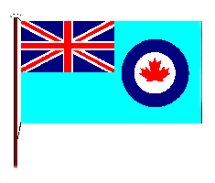
With integration and unification of all three Canadian armed forces in the mid-1960s, the RCAF ensign was officially "retired" on February 15th, 1965, coincident with the introduction of the new Canadian Maple Leaf flag. Although the ensign disappeared from Canadian military airbases, it continued in use with the RCAF Association. In 1972 the Association petitioned our Royal patron, Her Majesty Queen Elizabeth II, and in September 1973 the Queen decreed that the RCAF Association should adopt the former RCAF Ensign and henceforth be know as the "Association Ensign." At that time, the director of ceremonial for the Canadian Forces requested the Association to adopt a "stylized" maple leaf to replace the central leaf design utilized in the old RCAF roundel.

On January 1st, 1997, the Air Force Association ensign was copyrighted as the property of our Association, and registered under section 9 of the Canada TradeMark Act. The particulars are published in the TradeMarks Journal, Vol. 44, No. 2201 (No. 908 824)

SERGEANT SHATTERPROOF

Sergeant Shatterproof was the invention of RCAF cartoonist WO1 Ray Tracy, and was introduced to readers of Roundel magazine in 1949, shortly after the new magazine went into production. As the official magazine of the Royal Canadian Air Force, Roundel was seen by literally tens of thousands of Air Force people between 1949 and the early 60s when it ceased publication due to unification/integration.
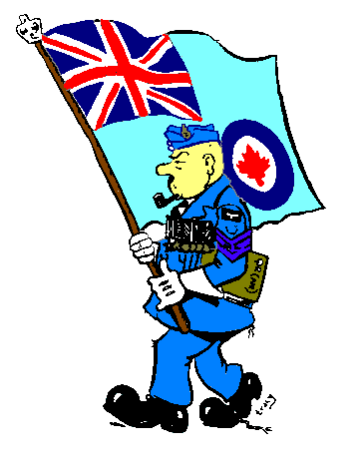 | Officer, airman, airwoman or veteran, Shatterproof was the spokesman for "the little guy," the irk on the hangar-line, the clerk in the office or the "sprog" pilot officer at flying school. Sgt. Shatterproof would not be tolerated in the politically correct Air Force of today. He spent too much time at the bar in the Sergeant's Mess, and he continually harassed "the brass" by speaking out on behalf of "the boys in the field." During his fiefdom at Roundel, Shatterproof often commented on activities within the RCAF Association. In fact, he was a Charter member of our esteemed "Moose Pelvis" Wing. and more than once donned his "blues, greys and gongs" to parade during the annual Battle of Britain commemoration.
Demoted from the rank of Warrant Officer 2nd Class, and demoted once again from the rank of Flight Sergeant, Shatterproof would never have been a contender for today's Medal of Military Merit. In fact, it took him 17 years to qualify for the Canadian Forces Decoration, routinely awarded to mark 12 years of good conduct or, as Shatterproof might say, "a dozen years of undetected crime!" Shatterproof is a throwback to simpler times. As a unilingual, pipe-smoking chauvinist "with an attitude," Shatterproof has no place in Canada's modern military. But he's got a big heart, a ready wit and he's a hard worker. We accept him, as he is, a proud Canadian, and an active, contributing member of the Air Force Association of Canada.

