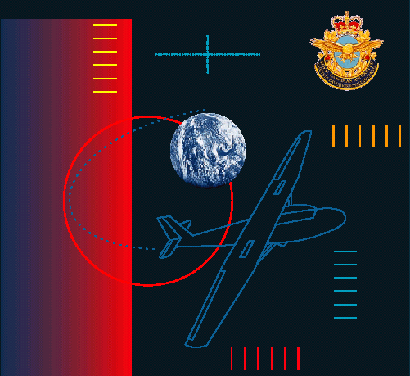
FLYING SCHOLARSHIP
Program Instruction Package

