TYPES OF WEATHER CHARTS

SURFACE WEATHER CHARTS

- includes: isobars (joins places of equal pressure), high and low pressure areas, air masses and fronts.

- shows actual conditions at a specific time

- the pressure pattern is representative of the atmosphere up to 3000 feet

- issued 4 times daily at 6 hour intervals

UPPER LEVEL CHARTS

shows actual wind flow patterns and temperatures aloft at various altitudes at a specific time

measured twice a day at 0000 Zulu and 1200 Zulu

PROGNOSTIC CHARTS
(Graphic Forecasts)

PROGNOSTIC SURFACE CHARTS (PROG)

- is a graphic forecast

- shows expected surface weather at a specific time in the future

- issued 48 hours before they are valid and a second revised chart is issued 12 hours later (36 hours before they are valid).

UPPER LEVEL PROGNOSTIC CHART (PROG)

- a graphic forecast of winds and temperatures aloft for a specific time

- prepared for specific high level altitudes

- issued 4 times daily 12 hours before valid
SIGNIFICANT WEATHER PROGNOSTIC CHART (PROG)

- shows forecast significant weather considered to be of concern to aircraft operations

- issued four time daily 12 hours before they are valid

METAR
Meteorological Aviation Weather Report

- taken and issued on the hour, every hour, at weather stations around the world

- an actual observation of current weather conditions taken by an accredited observer

- cloud heights are above ground

TAFS

Terminal Aerodrome forecast

- states in specific terms the expected weather conditions at a specific aerodrome

- covers a radius of five nautical miles around the aerodrome

- issued four times daily at six hour intervals

- valid for up to 24 hours

- cloud heights are above ground

FA
Area Forecast

- general forecast conditions over a particular area

- forecasts for various regions within the area

- cloud heights above sea level unless noted

- issued every six hours

- valid for 12 hours with a further 12 hour outlook

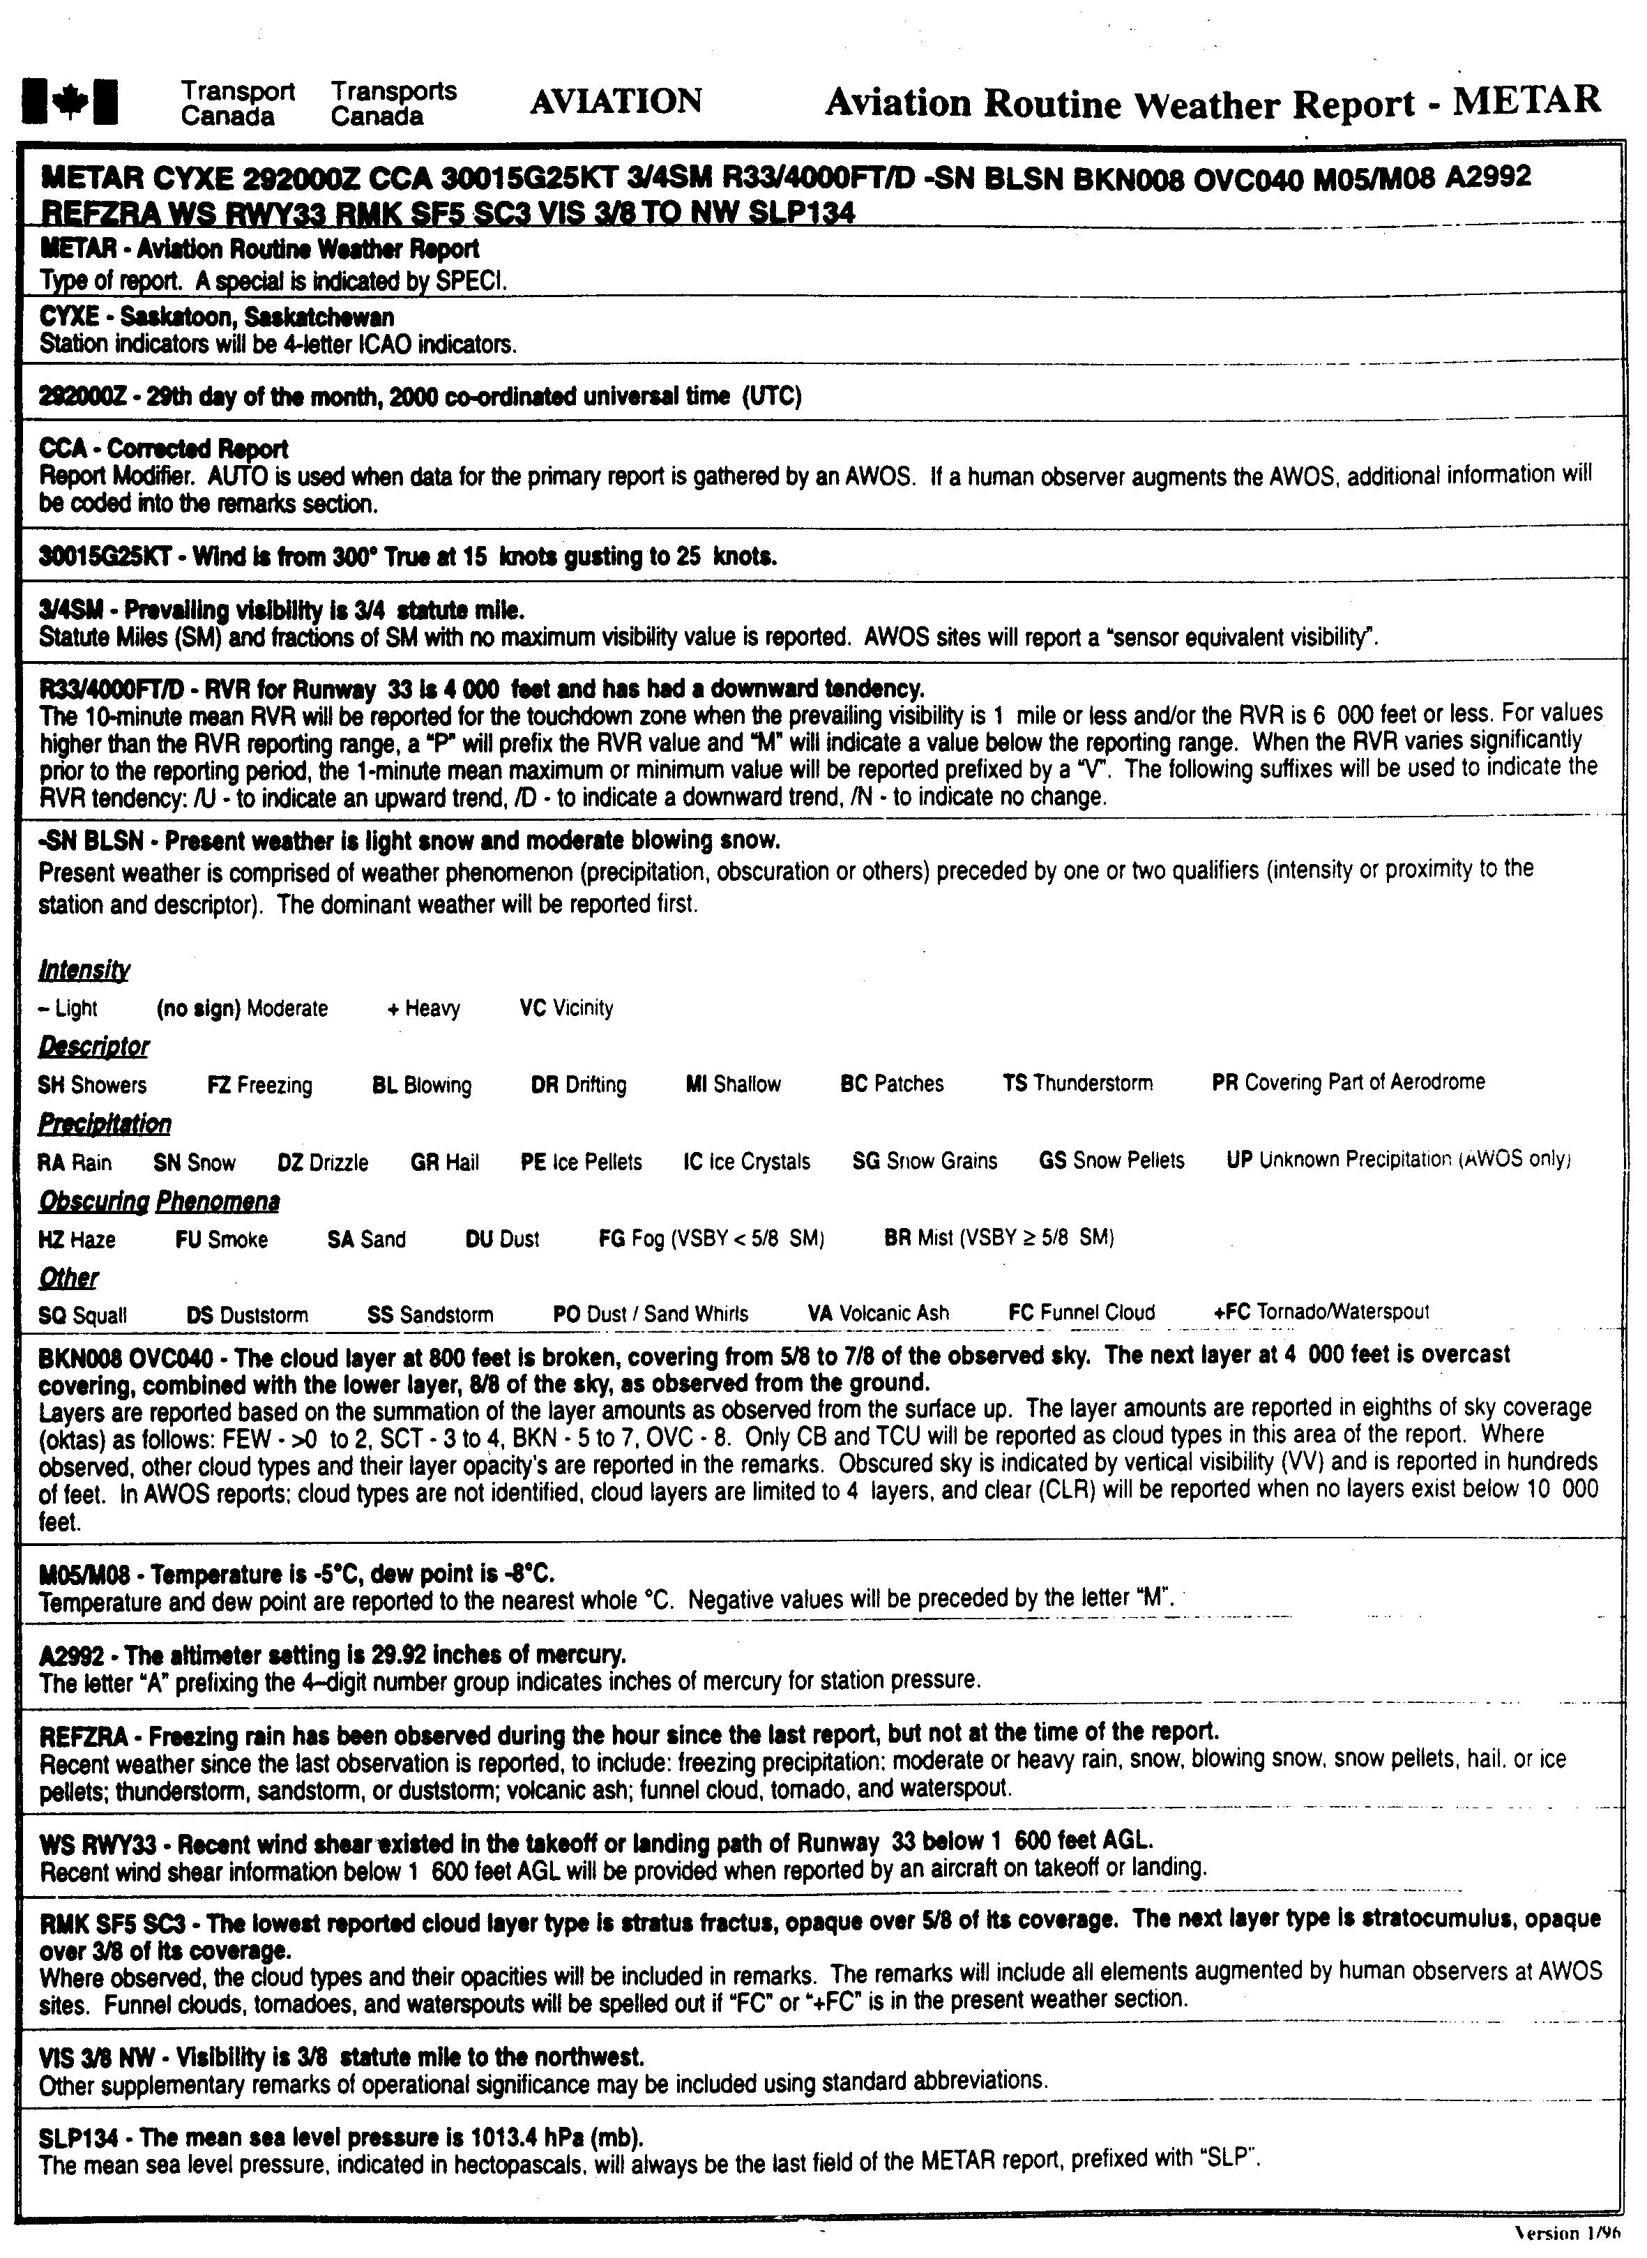
MET 403-13

