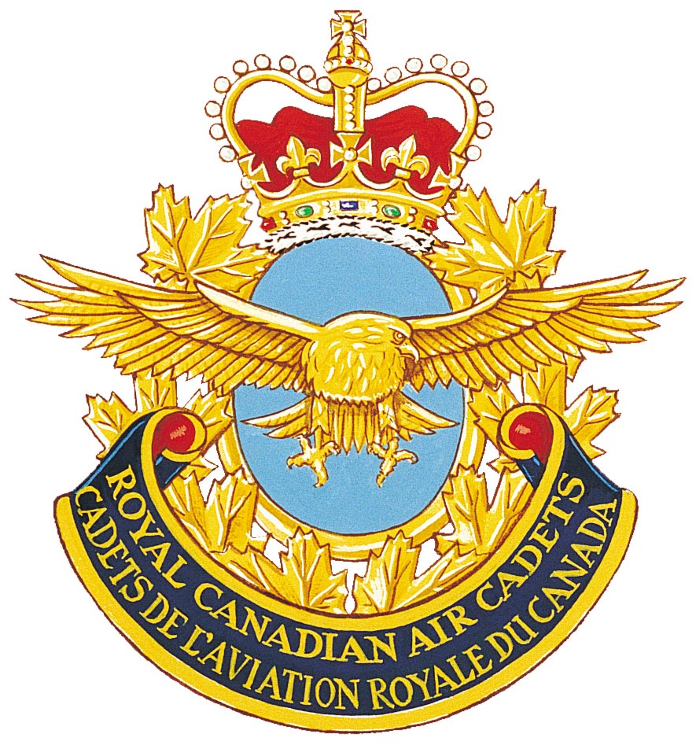

CURRENT AIR CADET PROFICIENCY LEVEL PROGRAM – MANDATORY SUPPORT TRAINING RESOURCE REQUIREMENTS

Proficiency Level | Supported Days/Weekends
Proficiency Level | 1 | 2 | 3 | 4 | 5 & 6  (1 Weekend) | 7 & 8  (2 Days or 1 Weekend) | 9 & 10  (2 Days or 1 Weekend)
One | Range | Citizenship | Familiarization Flying (Gliding)* | Sports | Aircrew Survival Weekend Exercise | SDA | CO’s Discretion
Two - Four | Sports
Five | Organize and Lead 2 activities for Levels One -Four |  |  |  |  | SDA | CO’s Discretion
 | Support Requirements
Bus | No*** | No | Yes | No*** | Yes | (There was no specific level of support for SDA activities. Each Det established their own policy for allocating and administering these funds.) | Yes (1 Rtn Trip)
Safety Vehicle | No | Yes | No | No | Yes |  | Yes
Accommodations | No | No | No** | No | Limited – only as emergency back-up in inclement weather if cost effective |  | CSTC/Service Quarters, or as per FTX
Rations | 1 Meal | 1 Meal | 1 Meal** | 1 Meal | 5 Meals |  | Max 5 meals
Training Facility | No*** | No | No** | No*** | Yes |  | 1 Day, or as per FTX
Training & Learning Aids | Yes | Limited | No** | Yes | Yes (Deliver Stores) |  | Yes (Deliver Stores)
Training SME | RSO if req’d | No | RCAOps | No | Yes |  | Yes

*Sufficient gliding days are generally scheduled to permit each cadet on strength the opportunity to glide once each training year.
**Accommodations and additional meals provided for units with long travel time to gliding centre; where cost effective, limited support may be provided for concurrent activities (e.g. sports equipment, range equipment/ammunition, pool fee, etc.
***Where the LHQ facility is not conducive to the type of training being conducted, reasonable admission fees/rental of an appropriate training facility in local area are supported, along with transportation to & from the facility.

UPDATED AIR CADET PROFICIENCY LEVEL PROGRAM – TRAINING DAY/WEEKEND RESOURCE REQUIREMENTS

Proficiency Level |  | Supported Days/Weekends
 |  | Mandatory Activity |  |  |  |  | Complementary Activity
 |  | 1 | 2 | 3 | 4 | 5 & 6  (1 Weekend) | 7 | 8 | 9 & 10  (2 Days) | OR |  | 9 & 10  (1 Weekend)
One |  | Combination of Mandatory Activities  (9 periods of Mandatory Level Training from applicable QSP) | Combination of Mandatory Activities  (9 periods of Mandatory Level Training from applicable QSP) | Familiarization Flying (Gliding)* | Inter-Squadron Skills Competition | Field Training Exercise | Combination of Complementary Activities  (9 periods of Complementary Level Training from applicable QSP) | Combination of Complementary Activities  (9 periods of Complementary Level Training from applicable QSP) | Inter-Squadron Skills Competition  OR  Elemental Day  OR  Combination of Both |  | Field Training Exercise
Two |  |  |  |  |  | Aircrew Survival Exercise
Three
Four
Five | Year 5
Five | Year 6
 |  | Support Requirements
Bus |  | No  (Note 3) | No  (Note 3) | Yes | No | Yes | No  (Note 3) | No  (Note 3) | No |  | Yes
Safety Vehicle |  | No | No | Maybe  (Note 4) | No | Yes | No | No | No |  | Yes
Accommodations |  | No | No | Maybe  (Note 4) | No | Yes  (Note 5) | No | No | No |  | Yes  (Note 5)
Rations |  | 1 Meal  (Note 6) | 1 Meal  (Note 6) | 1 Meal  (Note 6) | 1 Meal  (Note 6) | 5 Meals  (Note 7) | 1 Meal  (Note 6) | 1 Meal  (Note 6) | 2 x 1 Meal  (Note 6) |  | 5 Meals  (Note 7)
Training Facility |  | Maybe  (Note 3) | Maybe  (Note 3) | Yes  (Note 4) | No | Maybe  (Note 5) | Maybe  (Note 3) | Maybe  (Note 3) | No |  | Maybe  (Note 5)
Training & Learning Aids |  | Yes | Yes | Yes | Yes | Yes | Yes | Yes | Yes |  | Yes
Training SME |  | No | No | RCAOps | No | No | No | No | No |  | No
Note 3: Usually conducted at LHQ but sqn may occasionally select an activity that requires transportation to another location within the community or to an adjoining community and/or rental of a facility (gym, hall, etc.)
Note 4: Depending on gliding centre set up.
Note 5: Field accommodations (park or permit fee, cabin rental, porta-potties, etc.)
Note 6: Box Lunch, fresh rations, prepared meals, etc.
Note 7: IMPs.

